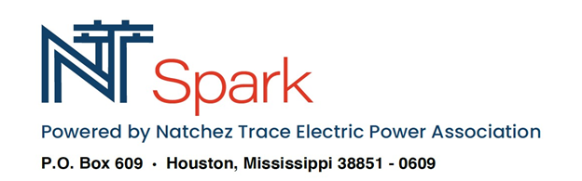
Please return this application by mail or drop off at your local office
662-456-3037
www.NTSPARK.COOP
COMMERCIAL – REQUEST SERVICE FORM

FIRST NAME LAST NAME DATE

HOME (SERVICE) ADDRESS MAILING ADDRESS (IF DIFFERENT) CITY STATE ZIP COUNTY CELL PHONE HOME (SECONDARY) PHONE EMAIL
NATCHEZ TRACE EPA ACCOUNT NUMBER
PLEASE SELECT OPTIONS BELOW:
WE ARE STILL WORKING ON OUR VOICE OFFERINGS! PLEASE DISCUSS YOUR NEEDS WITH US SO A PACKAGE CAN BE CREATED TO PROVIDE YOU WITH WHAT YOU REQUIRE.
(Check Only One)
BUSINESS:
PHONE

INTERNET

KEEP MY EXISTING PHONE NUMBER
GIVE ME A NEW PHONE NUMBER
**Small Business Packages-Defined as a business with fewer than 2 Phones**
Business Voice (First Line) $29.99 Additional Lines $19.99
Lines Required
**Large Business Packages-Defined as businesses with more than 2 Phones** Hosted Voice – Per Phone Cost $34.99 Lines Required NT Spark offers a full listing of commercial phone services. We can affordably accommodate whatever your business needs.

**Small Business Packages-Defined as a business with fewer than 2 Phones**
NT SPARK BASIC 100 Mbps $79.99
NT SPARK EXP BASIC 1 Gig $99.99 **Large Business Packages-Defined as businesses with more than 2 Phones** NT SPARK Business Premium 1 Gig $149.99 Static IP Address $9.99 Direct Internet Access 1 Gig $450.00

** Managed Wi-Fi Service Included in Above Prices **

Please Read and Check Where Applicable:
Must Agree to the Following:
I CONFIRM I AM THE OWNER OF THE PROPERTY WHERE SERVICE IS BEING REQUESTED OR HAVE THE PERMISSION FROM THE PROPERTY OWNER. I HAVE READ AND AGREE TO THE NT SPARK, LLC’S GLOBAL TERMS AND CONDITIONS AND ACCEPTABLE USE POLICY.
I AGREE TO RECEIVE AN E-BILL STATEMENT (VIA THE SAME EMAIL ADDRESS IN THIS FORM) AND NOT A PAPER BILL.
OPTIONAL: I WOULD LIKE TO SIGN UP FOR AUTOPAY VIA BANK DRAFT.

SIGNATURE DATE SIGNED
After submitting this application, you will be contacted at a later time to schedule an installation date.

